Conclusions we can make about Kickstarter campaign: -

The data provided entailed some interesting details pertaining campaign and its success factors. First right off the bat we come to understand what campaigns/projects are and whether they have been successful or not. I have come up with following conclusive observations:

* 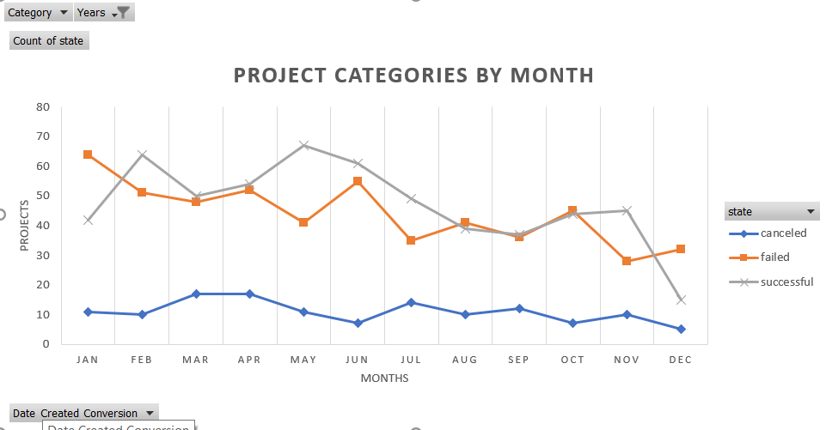Year 2015 proved to be most successful in terms number of campaigns completed but on the other hand this year had most number of failed projects as well. This indicates team had issues with bandwidth and management of teams handling projects. This year was very busy and fruitful, but team failed to seize the opportunities/momentum as number of project that closed and
* 50 new projects went live in 2017 proving to be positive besides this everything else was much lower in comparison to previous years. This indicates that currently we may not have as many campaigns running and to boost the current load since bandwidth seems to be there new campaign project are initiated.
* When it comes to Sub Categories Theater Plays play crucial role in success of given project. when nested chart is created for subcategories it clearly portrays that Plays outshine all other sub categories and way ahead of second-best sub categories which is Rock concerts.



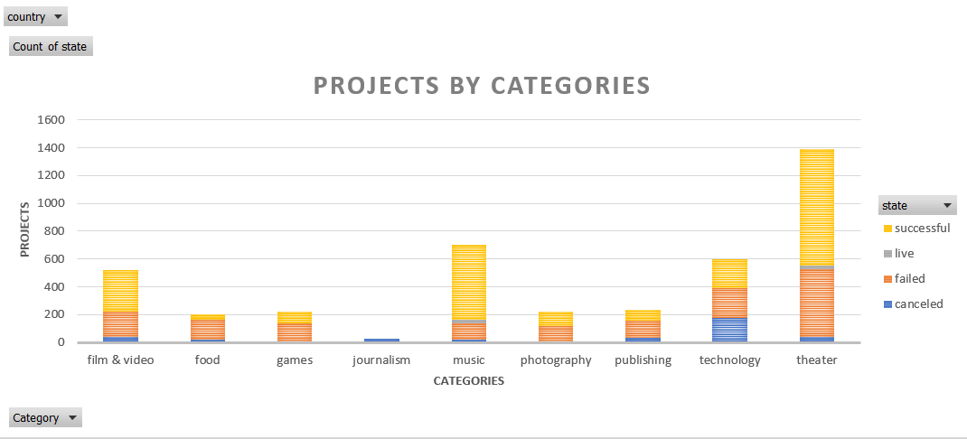When nested chart for Categories is analyzed one can clearly see that Theater and Music outshine others and outperform significantly. Technology has few successes but come with equal risk of project being cancelled/terminated and Journalism being least successful.

Limitations of this Dataset: -

There are few limitations to this dataset which limits us to make accurate conclusion on performance of the team and its campaigns years over years. Some that stood out the most are as follows:

* This dataset proves to be less successful in describing what these categories and sub category are in depth. Fo Eg if a category was successful than what were its reasons? Team members? Duration it took to prepare project before it was initiated etc. This hinders analyst from making good assertions on how categories/sub categories perform well when which factors are available or gone missing. We see flat data on whether they were successful, canceled failed or initiated but we can’t make sure of reasons behind these outcomes.
* What other thing we don’t see is expense accrued in preparation of a given project and to be more in depth how much of those expenses were allocated to Marketing, execution and operational expenses of running these projects/campaigns. Also data type such as staff picks what do they represent and goal amount provided doesn’t really provide insight into how were they calculated and nor we have nay details on amount pledged.

Other possible Graph/Charts that could be created.

* Pie Chart – This would relay more stories pertaining to campaigns such as :
  + Avg contributions per Campaign – This would provide insight into funding or pledged amount for each campaign and its category. This will help us to analyze as clients prefer to pledge more for which type of campaigns and its categories. Also we can make statistical assertion on if and when analysis as whether which type of campaign to launch more or to cut/cancel which ones out.
  + Yearly pie chart showing contribution of each category and sub category of campaigns - This could be used to articulate the composition/planning of a given year and how it has evolved year over year. We can also make out SWOT out of this by comparing each category worked on and launched compared to its outcome (successful, failed, canceled etc.)
* Scatter Plot Diagram- This chart would explain further on where campaign lacked or exceeded expecattions:
  + Scatter plot diagram plotting state of the project/campaign for a given year comparing against Categories can provide real inside into which categories outperformed others and to further explain we can also plot pledged amount in diff color to compare against categories. This way we can filter out top performing campaign with lowest to highest pledged amount.